**

**Mathematics Specialist Unit 1**

# Test 1

**Vectors**

|  |
| --- |
| **Name: ______________________ Total Marks:__________** |
|  |
|  |

**Task type: Response**

**Time allowed for this task:** 60 minutes, in-class, under test conditions

Section One: Calculator-free 25 minutes (23 marks)

Section Two: Calculator-assumed 35minutes (29 marks)

**Materials required:** Calculator with CAS capability (to be provided by the student)

**Standard items:** Pens (blue/black preferred), pencils (including coloured), sharpener, correction fluid/tape, eraser, ruler, highlighters

**Special items:**  Drawing instruments, templates, notes on two unfolded sheets of   
A4 paper, and up to three calculators approved for use in the WACE examinations

**Marks available: marks**

**Task weighting: 4%**

**Section One : Calculator Free Marks 23**

**Time Allowed Reading 2 minutes**

**Working 23 minutes**

Question 1 [1, 1, 1,2]

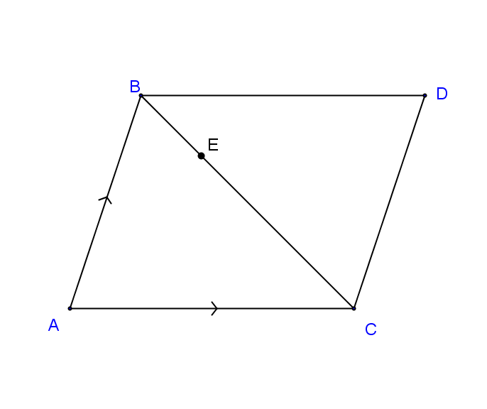

ABCD is a parallelogram with E a point on BC such that BE:EC = 1:3.

If $\vec{AC}= a$ and $\vec{AB}= b$**.** Express in terms of $a$ and $b$

$\vec{DC}$

$\vec{AD}$

$\vec{BC}=$

$\vec{DE}=$

Question 2 [3]

The vector $a=12i +5j$, Find the unit vector parallel to $a$ but in the opposite direction.

Question 3 [1,1,1,2,2]

Given $a=<2, 4>, b=<5, -1>and c= <-7,2>. Find$

$a-b$

$-2b$

$3c$

$4a-3b$

$\left|a\right|+\left|c\right|$

Question 4 [2, 1, 1, 4]

Given than **v** = -3**i** +4**j** and **u** = 7**i** – **j**, find:

1. |**v** + **u**|.
2. The unit vector parallel to **v** + **u**.
3. A vector that is parallel to **v** + **u** but with magnitude of 8.
4. **v** in terms of **s** and **t** where **s** = -**i** -2**j** and **t** = -**i** + 8**j**.

**Section Two : Calculator Assumed Mark 29**

**Time Allowed Reading 3 minutes**

**Working 32 minutes**

Question 5 [5]

Vector $ai +bj$ is the same magnitude as $5i+12j$ and is in the same direction as $-2i+3j$**.**

Find the exact values of $a$ and $b$.

Question 6 [3, 2]

A force of 45N is acting on an object in the direction of 220 $°$.

1. Write this force in component form where $i$ is a unit vector due east and $j$ is a unit vector due north.
2. A second force acts on the object to keep it in a state of equilibrium. What is the magnitude and direction of this force?

Question 7 [6]

Adam leaves home and walks 2km on a bearing of 190 $°$. He then travels 3.2km on a bearing of 070 $°$. He then walks directly home from this point. How far will he have to walk home and on which bearing?

Question 8 [3, 3]

A boy intends to swim across a river of width 20 metres to the opposite bank. The river flows at a steady rate of 1 km/h. The boy can swim at a steady speed of 2 km/h.

•

1. In what direction should the boy be headed so that he ends up at the opposite bank directly opposite to where he started off?
2. Find the time taken for the swim in part a).

Question 9 [5,2]

Three forces act on an object in a flat plane. **F1** has a magnitude of 8 newtons and acts on a bearing of 070, **F2** has a magnitude of 12 newtons and acts on a bearing 126 and **F3** has a magnitude of 10 newtons and acts on a bearing 320 $°$.

1. Find the magnitude and the direction of the resultant force.
2. Find the magnitude and direction of the single force that will keep the object in equilibrium.